Chassis Clamps

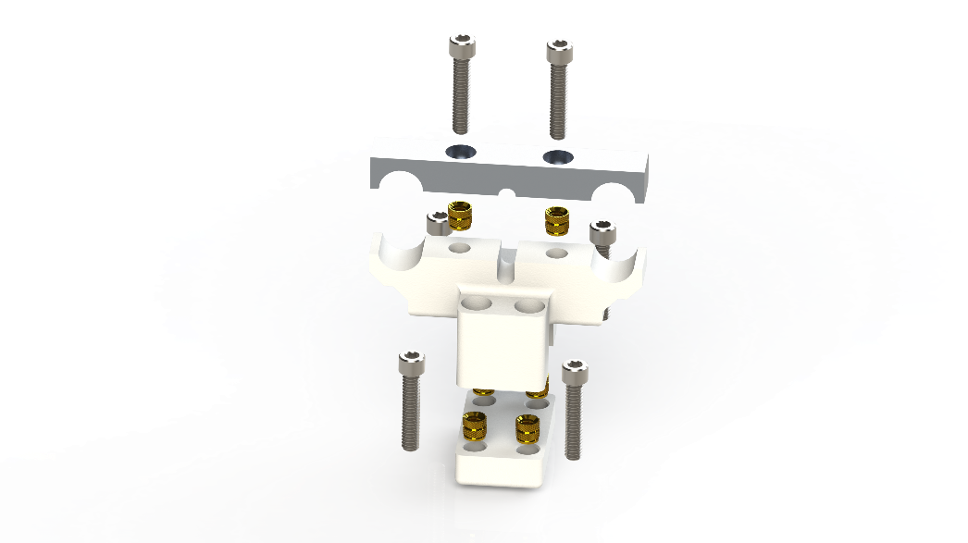Summary:

The chassis clamps connect the sensor package to the robot chassis. They should be securely attached to the robot chassis and then left in place unless it becomes necessary to conduct repairs.

**Parts List:**

* (6) ¼-20 x 1.25in bolts. (18/8 suggested)
* (6) ¼-20 x 0.312in heat set inserts.
* (1) Upper Clamp (fabricated)
* (1) Middle Clamp (fabricated)
* (1) lower clamp (fabricated)

**Fabrication Notes:**

Upper Clamp – This part should be machined if possible, but can be printed with the counter bores face down if need be.

Middle Clamp – This part should be printed with the slot facing down, and infill enabled. Heat set inserts should be should be pressed into place at a temperature of 350c.

Lower Clamp – This part should be printed with the filleted side face down. Heat set inserts should be should be pressed into place at a temperature of 350c.

**Assembly Notes:**

1. Place the middle clamp over forward or rear flying bridge as appropriate. Press until firm.
2. Hold the lower clamp against the underside of the flying bridge.
3. Apply Loctite blue to 4 screws, and use them to tension the middle clamp against the lower clamp. Tighten until secure.
4. When appropriate use Loctite purple to secure the sensor carriage in place with the upper clamp. The Loctite should be removed and re-applied every 5 cycles or before major demos.

Lidar Cage

Summary:

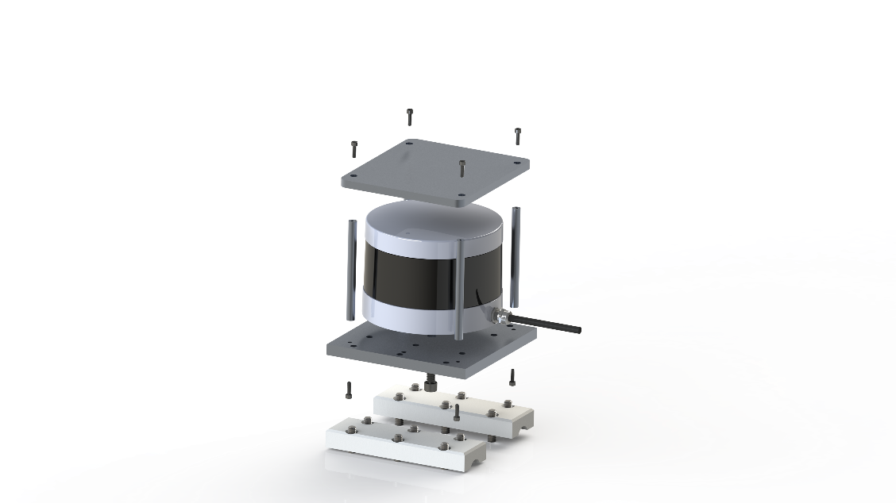The Lidar Cage connects the Velodyne Lidar to the rods, and protects it from damage in the event the robot rolls. This page does not cover attaching the cage to the rods. Please see the page on rod clamps for more information.

Note: Socket head cap screws can be exchanged for button head cap screws as needed.

**Parts List:**

* (8) 4-40 x 3/8in socket head cap screws. (18/8 suggested)
* (1) ¼-20 x 3/8 socket head cap screw. (18/8 suggested)
* (4) 4-40 x 3” x ¼” OD female standoffs.
* (2) 5/32 x 3/8” dowel pins.
* (1) Lidar Plate. (connects LIDAR to rods)
* (1) Cage Lid. (sits atop standoffs)

**Fabrication Notes:**

Cage Lid – This part is meant to be machined from ¼” stock using a fixture plate or vise. All of the holes should be drilled in one operation. Tolerances should be held to less than +-.01”.

Lidar Plate – This part is meant to be machined from 3/8” stock using a fixture plate or vise. All of the holes should be drilled in one operation. Tolerances should be held to less than +-.005”.

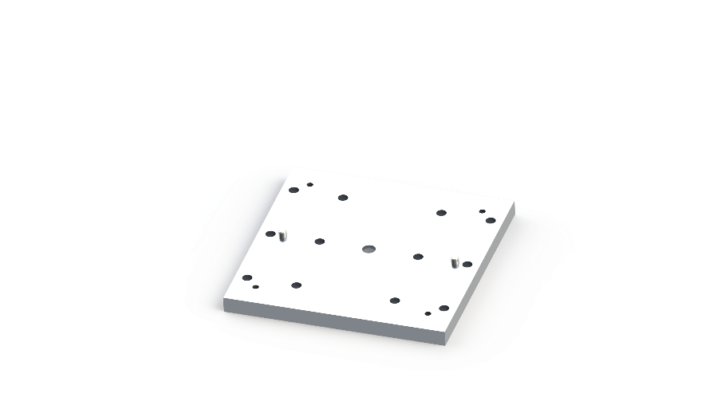Using locktite 638 retaining compound or similar fix the 5/32 dowel pins into their corresponding holes in the Lidar Plate. They should extend above the plate by about 1/8” (+-1/16”). Wait 30 minutes until dry.

**Assembly Notes:**

1. Register the circular hole on the bottom of the Puck to one of the pins. Then rotate the Puck slowly until the slot on the other side interfaces with the other pin. Then place the plate and Puck on a table with the puck face down.
2. Using Loctite blue secure the Puck to the plate using a ½-20 x 3/8 socket head cap screw in the central counterbore. This connection should be snug.
3. Use 4-40 x 3/8” socket head cap screws to connect the standoffs to the Lidar plate. Loctite blue, or Loctite purple should be used on the threads. Then, flip the plate over so the LIDAR is face up.
4. Using more 4-40 x 3/8” cap screws, and your preferred Loctite secure the cage top.